HEALTH AND ECONOMIC IMPACTS OF A SIMULATED RDD
INCIDENT IN FAIRFAX COUNTY, VIRGINIA

Dr. E. J. Bentz, Jr., C. B. Bentz, and T. D. O’Hora
E. J. Bentz & Associates, Inc.
Alexandria, Virginia USA

Abstract:
This paper describes a site-specific analysis of a simulated detonation of a small radiological dispersal device (RDD) or “dirty bomb.” The analysis described here for Fairfax County, Virginia has also been performed for other locales. These analyses form the basis for planning for recovery from a radiological terrorist incident.

The authors describe the analysis that was performed for Fairfax County, Virginia; the findings as to the health and economic impacts of this simulated incident; and the implications as to unique problems that would be expected to be encountered in responding to a radiological terrorist incident. The authors conclude by recommending the benefits of developing site-specific RDD Consequence Management and Recovery Plans.

Description of Analysis:
Stimulated by informal discussions with county officials, E. J. Bentz & Associates, Inc. (EJB&A) developed a methodology to conduct an assessment of the impacts of a terrorist RDD incident in Fairfax County, Virginia. Realistic RDD incidents were simulated and mapped utilizing computer models. The impacts and risk assessment subsequently conducted included:

- A health risk assessment (short and long term) of the population at risk;
- An economic impact assessment of residential property at risk;
- An assessment of the costs to clean-up the decontamination to the EPA maximum allowed dose standard using technologies appropriate for actual local land use patterns; and
- An assessment of the maximum time available (based on health risks) for cleanup prior to an alternative decision to abandon and demolish.

In order to perform these assessments, EJB&A developed an integrated set of predictive models on a GIS street-level platform. These models included both publicly available models (modified for these locale-specific Fairfax County assessments) as well as proprietary models and methods. The sequential steps of the simulation model included: detonation; atmospheric dispersion, re-suspension, and deposition; multi-pathway, isotope-specific, human health dose assessment; and engineering technology- based remediation cost estimation (the sequential steps are depicted below).
The quantities and types of radioactive materials necessary to construct an RDD can be found and are readily accessible in most countries, including the U.S. A single, relatively small (1375 Curies) Cesium-137 (Cs-137) radioactive source was dispersed by a small explosive charge in the simulation discussed herein. The radionuclide and size of the radioactive source were chosen for the simulation because:

- Such sources are readily available within the community (Cs-137 is a common medical radiopharmaceutical).
- The relatively small size makes the source easy to handle and conceal.
- The radionuclide and source size reflect a well-known, historical incident that took place in Goiania, Brazil in 1987 (dispersal of materials from an abandoned, identically-sized Cs-137 medical source that was opened and accidentally spread over a wide area by scavengers, their families, and friends).

Findings:
The primary health risks of the simulated RDD incident would be long-term increased risks of developing both fatal and non-fatal cancers for people exposed to contamination from detonation of the RDD:

- 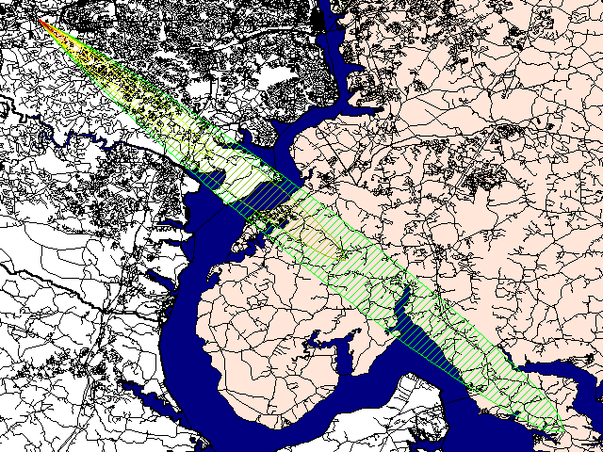Under typical (most frequent) wind conditions, the contamination was estimated to cover over 7.7 square miles in the heart of Fairfax County, extending into neighboring areas of Washington, D.C. and Maryland over a period of ten hours.
- The number of County residents at risk from contamination was estimated to be greater than 19,500.
- The number of contaminated residential homes that would require cleanup or abandonment was estimated to be greater than 7,000 units, with an estimated current market value of more than $2 billion.
- The cost to clean up these contaminated residences was conservatively estimated to be more than $385 million (clean-up/decontamination of commercial properties was not included in this preliminary analysis).
- Although we did not quantitatively estimate cleanup costs for commercial properties, business and employment losses, declining real estate values, tax base losses, etc., other studies have shown that the overall economic impacts from contamination and cleanup could reach into the billions of dollars in a thriving economic center such as Fairfax County.
- 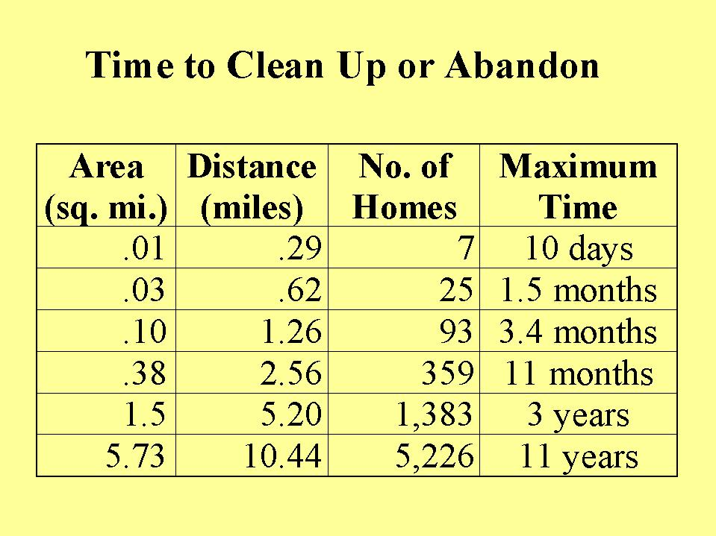The maximum time available to abandon or clean up an area so that residents would remain within a permissible health dose standard varies by proximity to the incident.
- The closest-in area (approximately .01 square miles, out to a distance of .3 miles downwind) is estimated to have up to 10 days to decontaminate before occupants would reach the 20-year protective action guideline for dose; whereas the farthest-out area (a 5.7 square mile area at a maximum distance of between 5.2 and 10.44 miles downwind) is estimated to have up to 11 years to clean-up (see table at right).
- Within the initial two hours of incident response subsequent to detonation of the simulated RDD, emergency responders within 100 feet of ground zero would be dosed above the short-term exposure standard.

Implications:
Even a small, relatively accessible device causing very limited immediate destruction or loss of life, could inflict demonstratively significant long term health impacts and significant economic damage to Fairfax County. The damage could only be mitigated by expensive and timely clean-up demonstrated to cost hundreds of millions of dollars. The alternative would be large-scale abandonment and subsequent economic closure of the area, with losses assumed to measure in the billions of dollars.

Because an RDD “incident” is “on-going” until cleaned up (results in cumulating doses in individuals from the contaminated areas), swift and efficient recovery is paramount. Emergency preparedness must include planning for the recovery period. The longer cleanup takes, the higher the health risks. In addition, the threat of spreading the contamination to adjoining areas increases, and for certain isotopes, the cleanup costs increase.

Since 9/11, a great deal of progress has been made toward planning, developing, and coordinating federal, state, and local roles in responding to the terrorist detonation of a WMD or RDD in the U.S. (e.g. Presidential Directive 39 and the Terrorism Incident Annex to the Federal Response Plan specifically define the roles that federal agencies will play in responding to an act of terrorism). However, it appears that very little work has been done by federal, state, and local authorities toward planning for management of the rather unique intermediate and long-term problems and consequences that could result from detonation of an RDD, or toward coordinating federal criminal investigative needs with the need for expedited cleanup:

- RDD incident consequence management and recovery efforts face unique problems and issues due to the long-term exposure and health consequences that could result from an incident. However, federal disaster relief assistance and consequence management programs are geared to respond to short-term consequences occurring from most natural and man-made disasters.

- Initial federal disaster and emergency relief assistance, available through FEMA under the Stafford Act, is primarily directed toward emergency response and stabilization (saving lives and protecting property).

- Unlike the 9/11 incident, private insurance would not cover the bulk of cleanup and recovery costs. Incidents involving the release of radioactive materials would not be covered due to a standard exclusion included in most insurance policies.

- While additional funding is available to the County for repair, restoration, reconstruction, or replacement of public facilities (e.g. county buildings, roads, bridges, parks, etc.), federal assistance to individuals and private businesses is limited, and is mostly available in the form of small grants and loans that would not even begin to cover uninsured losses that could result from an RDD.

- Personal experiences of emergency responders to the Oklahoma City and 9/11 terrorist incidents indicate that federal criminal investigative needs may clash with, and may severely impede, efforts to perform the expedited cleanup required to mitigate long-term health and economic consequences from an RDD incident.

Recommendations:
Unlike conventional threats- including that demonstrated by the 9/11 incident - the threat from an RDD continues long after the initial detonation. Conventional governmental crisis and consequence management plans must be modified and supplemented to meet the unique, short and long-term adverse impacts from detonation of an RDD, and include prepared recovery plans. Further, mechanisms for the funding of recovery operations (unlike the funding of crisis management, or incident response) will have to be revisited due to the lack of available commercial insurance for radiological terrorist incidents.

To address the unique problems and issues involved in RDD consequence management and recovery, EJB&A believes that government authorities should develop an RDD Consequence Management and Recovery Plan. An RDD Consequence Management and Recovery Plan could (among other things):

- Create an outreach program and materials for educating the public on appropriate conduct and activities to (for example):
- Decrease the spread of radioactive materials to uncontaminated areas;
- Limit the exposure of individuals who live in or visit contaminated areas prior to cleanup;
- Assist in decreasing the contamination and thus exposure in more lightly contaminated areas (for example, by timely mowing of lawns, and scrubbing off sidewalks, driveways, and roofs).

- Provide a coordinated system for sampling, estimating, and mapping the concentrations in contaminated areas. As our analysis has demonstrated, these activities provide the basis for establishing the schedule and priorities for evacuation and decontamination.

- Provide an initial identification and description of cleanup technologies/methods available for various radionuclides and contaminated media, and resulting dose reduction effectiveness.

- Include feasibility studies, based on the above information, to determine which technologies/methods are appropriate for specific radionuclides/compounds and concentrations for specific geo-political areas and infrastructures.

- Estimate the cost of remediation associated with the use of the above-identified clean-up technologies for the identified areas.

- Identify the resources (including personnel, equipment, training, and funding) that will be required for cleanup and recovery operations and develop a plan and contingencies for securing the required resources.

- Provide a methodology for “triage” (i.e., deciding which RDD contaminated areas will be abandoned and which will be cleaned up, and in what order and timeframe).

- Identify procedural and legal impediments to expedited and cost-effective cleanup or abandonment operations, and develop and propose appropriate legislation and/or regulations to modify or supplement the existing procedural and legal framework.

About the Authors:
E.J. Bentz & Associates is a small management, scientific, and technical consulting firm located in Fairfax County, Virginia since 1980. Dr. Ed Bentz, the primary author, is a nuclear physicist. He is supported in the reported effort by long-time analytic staff. We can be reached at (703) 455 – 7469 or at info@ejbentz.com.

Acknowledgements:
We would like to thank Fairfax County Supervisor Elaine McConnell for her on-going and encouraging interest in this effort. We would also like to thank members of the Fairfax County Fire and Rescue and Police Departments for contributing to the dialogue examining issues relevant to this effort.

