
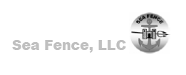

SeaFence: Non-Lethal Area Denial to Small Boats
General Dynamics- Ordnance and Tactical Systems (GD-OTS) is pleased to present information on a lightweight, portable sea barrier to the National Defense Industrial Association.

Executive Summary
SeaFence, LLC has developed a proprietary concept to stop fast moving surface threats in support of seaward force protection. GD-OTS will be the prime contractor and system integrator responsible for system development, qualification, manufacturing, and maintenance.

SeaFence uses a new approach to stopping an attacking fast boat which is fundamentally different from the methods currently employed. Current systems are designed to stop a boat by absorbing and dissipating the boat’s kinetic energy within the barrier system. This approach requires a massive and/or complex barrier structure. SeaFence uses a simple net and sea anchor system to plunge the boat into the water therefore using the water to absorb the kinetic energy.
Current approach vs. Sea Fence approach. This figure illustrates the fundamental difference in the light weight Sea Fence system and current massive systems.
Massive barrier
Attacking boat momentum
Current massive barrier approach
Sea Fence
Sea Fence light weight approach
Attacking boat momentum

The resultant system is a light weight, low cost system that is rugged, easily deployed and maintained.
It will be light enough to be deployed, including moorings, by one small boat with as few as a two-man crew. No heavy cranes or tugs will be required.

SeaFence is designed to stop repeated attacks by small boats traveling at high speeds. A five degree of freedom mathematical model demonstrates successful boat capture. Additionally, one tenth scale model testing resulted in numerous boat captures in fewer than two boat lengths with no damage to the barrier.
SeaFence can be easily be customized to meet unique threat requirements. Features such as fence height, sea anchor size, and plasma rope thickness can be modified to capture larger vessels traveling at lower speeds.

The system is ready for full scale proof of concept testing.
Technical Direction
When the SeaFence is struck by a fast moving boat, the bow is caught in one of the open loops of the net. As the net is pulled forward, a sea anchor is pulled out of its deployment canister and immediately opens applying a heavy tension on the anchor line. The deployed sea anchor moves only a few feet while the boat moves forward. This action pulls the bow downward causing the boat to plunge downward into the water. The hydrodynamic drag on the bow and hull cause the boat to come to a stop within 2 boat lengths of travel.
Sea Fence Schematic. This figure illustrates the Sea Fence configuration before capturing the small boat.
Sea Fence Schematic. This figure illustrates the Sea Fence configuration upon capturing the small boat.

There is only a minimal force transmitted to the SeaFence mooring system, which can be designed to merely hold the barrier in the desired position. This greatly reduces the size, weight, and complexity of the system.

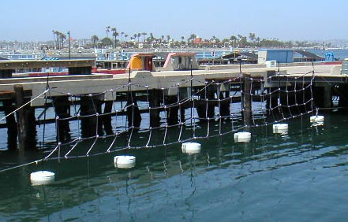
Buoys
Sea anchor lines attached to sea anchors
50 ft wide capture net weighs 90 lb
50 ft full scale prototype located at SPAWAR System Center Point Loma, San Diego. . This section has been undergoing environmental testing since May 2002. This photograph was taken at the time of deployment.

Relevance
Since the attack on the USS Cole in October 2000 and more recent terrorist threats against Naval Stations and related facilities the Navy has increased its attention toward seaward security. Naval forces such as the reserve Naval Coastal Warfare and the Coast Guard Port Security Units are challenged to provide continuous surveillance and force protection to hundreds of facilities in the US and overseas.

Current fixed systems being deployed such as the traditional log boom, the Port Security Barrier, and the Dunlop Ship Fender Barrier System require heavy cranes and tugs to install and maintain. These systems are expensive to install and maintain.

The SeaFence system could offer the Navy, Coast Guard, and commercial companies a low cost, portable, easily deployed sea barrier. The system relieves the requirement of providing continuous seaward security presence and could save hundreds of thousands of man-hours spent on surveillance.

It could also be possible to develop a pack-and-go SeaFence system that could be deployed by Expeditionary Forces such as Inshore Boat Units (IBU) and the Maritime Security Force (MSF). These expeditionary units often provide temporary seaward force protection to deployed units or naval facilities overseas. SeaFence could be a valuable force multiplier at a minimal cost. The pack-and-go variant could be available to commercial companies and used to protect yachts or other high value assets.

Synopsis of qualifications based on accomplishments
GD-OTS is currently working on a number of initiatives relating to non-lethal technology to support Force Protection/Physical Security applications. GD-OTS is in production of the Portable Vehicle Arresting Barrier (PVAB, M1) for the Army and Marine Corp. The PVAB is a non-lethal, “soft catch” net system used to stop vehicles that attempt to run through a checkpoint or facility gate. GD-OTS will leverage experience gained from the PVAB program (development, type classification, and production) to ensure that the SeaFence meets all of the customer’s operational and logistics support requirements.

Contact:
New business
Mike Willey
General Dynamics OTS
(425) 216-7374
Mike.willey@red.gd-ots.com

Technical information:
Mauricio Delgado
General Dynamics OTS
(425) 216-7316
Mauricio.delgado@red.gd-ots.com

