TAURUS KEPD 350 – a summary of the official system verification results
by Friedrich-W. Koch, TAURUS Systems GmbH

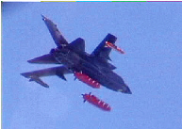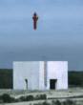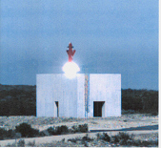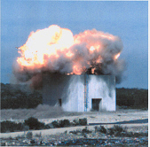
This paper describes the unique capabilities of the Taurus KEPD 350 modular stand-off missile for precision strike and the test results leading to the official final system verification completed in March 2004 by the German customer.
Taurus KEPD 350 provides outstanding air power to Tornado, Eurofighter, F/A 18, Gripen and other combat aircraft. Series production deliveries to the German Luftwaffe will begin as scheduled in November 2004. They will achieve with Taurus the capability to effectively combat heavily defended high-value, stationary point and area targets in ranges exceeding 350 km without exposing its aircraft and crews to enemy air defences.
With the final system verification campaign Taurus has proven its full system capabilities under extreme test conditions. Within the framework of the campaign the complete mission sequence from mission planning to high precision combat of a bunker target was successfully demonstrated. The missiles, the mission planning system and the ground equipment were identical to the series configuration. The system verification trials which have since 1999 continuously proven the evolutionary development steps including integration on the Tornado are herewith successfully completed.
Throughout the successful March trial, Taurus KEPD 350 utilised its unique Tri-Tec navigation system, combining GPS, terrain-reference navigation and image-based navigation, including sections of more than 100km with the GPS receivers switched off completely. The extreme precision of the missile after a cruise flight over its entire operational range was proven beside the fact that the missile was intentionally released with a significant offset, some kilometres away from the nominal release point planned with the mission planning system.
Safe missile releases out of a twin configuration of the Tornado carrier aircraft at a high flight altitude of approx. 25,000 feet and a speed of 0.67 Mach and at a low flight altitude below 1,000 feet and a speed of 0.83 Mach were performed. The agility and stability of the missile flight mechanics were proven over a wide spectrum of flight profiles. The missiles performed speeds ranging from Mach 0.65 to 0.95 at flight altitudes between less than 100 feet and approx. 25,000 feet and under high lateral and vertical acceleration. They also carried out terrain-following flights at an extremely low level and various pop-up manoeuvres with apex heights up to 12,000 feet.
The accuracy of hitting the target and the penetration effectiveness of the Mephisto warhead system were also impressively confirmed. Target detection, target identification and a highly precise final attack profile, the initiation of the pre-charge at the defined stand-off distance for perforation of soil and concrete, and follow-on penetration of a predefined number of different layers, followed by the initiation of the main-charge in the lower storey were successfully demonstrated. Taurus is equipped with the MEPHISTO warhead that is fitted with the Programmable Intelligent Multi-Purpose Fuze (PIMPF) currently the only programmable, layer counting and void detecting hard target fuze which is completely qualified and in series production.

